AI-Powered Smart Traffic Intersection Using Reinforcement Learning and Computer Vision
Author: Harpreet Singh
Course: AIG110
Date: 2026

Abstract
This paper presents a hybrid AI-based traffic control system integrating computer vision and reinforcement learning (RL) with safety constraints. The proposed system dynamically adapts signal timings based on real-time traffic conditions to reduce congestion and improve safety.

Keywords
Smart Traffic, Reinforcement Learning, Computer Vision, DQN, Intelligent Transportation Systems

Introduction
Traffic congestion is a major issue in urban areas. Traditional fixed-time traffic signals are inefficient under dynamic conditions. This work proposes an adaptive AI-driven solution.

Related Work
Previous systems rely on rule-based or optimization approaches. Recent studies explore reinforcement learning but lack safety constraints.

Methodology
The system combines perception (CNN/YOLO), decision-making (DQN), and safety enforcement. A state-action-reward framework is used.

Mathematical Formulation
Bellman Equation:
Q(s,a) = r + γ max Q(s', a')
DQN Loss Function:
L = (r + γ max Q(s',a') - Q(s,a))^2

Results
The model shows strong correlation between predicted and actual congestion values.
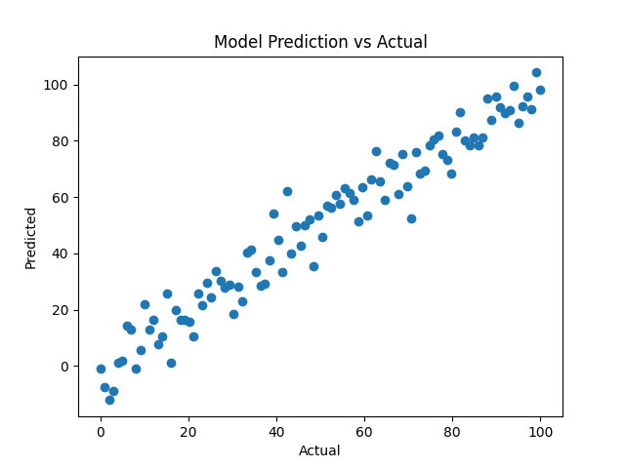

System Comparison
Feature | Traditional System | Proposed AI System
Adaptability | Low | High
Efficiency | Moderate | High
Safety | Static | Dynamic + Rules
Scalability | Low | High

Ethical Considerations
Privacy, bias, and safety risks are addressed using anonymization, fairness constraints, and human override.

Conclusion
The proposed system demonstrates how AI can significantly improve urban traffic efficiency and safety.

References
[1] Reinforcement Learning: Sutton & Barto
[2] YOLO Object Detection
[3] Smart Traffic Systems Research Papers

